AI for Developers – January 2026
Individual Project Assignment

Project Overview
checkmAIte is an AI-powered chess analysis platform designed to help players play, review, and learn from chess positions in a single, streamlined experience.
The experience is delivered through a modern, responsive interface centered around an interactive drag-and-drop board, clear evaluation feedback, and move navigation—making it practical to study positions, revisit saved games, and improve consistently.
The platform is built on top of the Stockfish 18 chess engine, which provides strong position evaluation and best-move suggestions. This engine foundation powers both ‘Play vs Bot’ (with adjustable difficulty) and the analysis experience, where users can review evaluations, explore multiple top candidate moves, and learn by comparing alternative lines.
Key capabilities include:
• Play vs Bot: choose player color and difficulty, play full games, and navigate the move history to review decisions.
• Analysis Board: analyze any position with real-time evaluation feedback and suggested best moves to explore alternatives.
• AI Coaching Chat: ask natural-language questions about the position and receive contextual guidance and commentary.
• Save & Resume: save positions/games with metadata and load them back into play or analysis workflows.
• Customization: personalize board appearance and user preferences for a comfortable study environment.
• Accounts & privacy: authenticated users keep saved games and settings tied to their profile.
The platform integrates a chess engine for evaluation and best-move suggestions, an optional external AI provider for coaching chat, and a database-backed account system for persistent saved games and preferences.
System requirements:
• Docker Desktop (or equivalent) to run the local services/database via containers.
The whole project was built only using Github Copilot, because I have a Pro version and have access to better models that was needed.

System Architecture – Modules
Before all these modules were created, I set up the process of initializing the project by adding first the Next.js expert agent and a skill for web-design-guidelines that agent should use for all best practices. In the plan regime we just place all the needed infrastructure for the future front-to-back end APIs, authentication, engine configuration, modes and DB. For this part I used better model – Claude Opus 4.5 in Plan mode, then after discussing what I want to achieve I change regime to agent – Next.js expert with Opus. His task was to create all the needed infra leave comments on top of the methods and then to not implement it. Only to implement infrastructure + modern UI of a web app with a chess board in the center.
Main modules:
• Gameplay & UI module (Next.js App Router + chess state):
Here my approach was to give a good detailed prompt to the Next.js expert agent (Claude Sonnet 4.5) in the beginning of the project, so he can properly implement the board state, playing the core game of chess with rules. On a plan mode I told him to suggest me a way of implementing this idea choosing everything. With a lot editing of the plan, we then have a running game of chess with rules applied.

• Engine analysis module (Stockfish 18):
In this module, first in plan mode we create a plan of how to add this engine in our app. In this position we have a game board and figures moving, but we need the engine to suggest our best moves. The plan was simple to add a Stockfish WASP Engine, so we can have proper best moves based on position of the figures and evaluation score. The task was very complicated with a lot of details that needed to be strictly followed, that’s why I choose to use Claude Opus 4.5 again.

• Backend/API module (Next.js Route Handlers):
In this module I primarily use GPT 4.1 with plan mode first and then switching to Next.js expert agent to execute the plan.
Giving APIs are not so hard to implement with little to no mistakes the agent creates it well.

• Authentication & security module (NextAuth + security practices):
In this module I choose Claude Sonnet 4.5 in plan regime and then I implement it using the GPT 4.1 in Next.js expert. Given that I need Authentication for users only to log in and have sessions. Given that in my core plan of the project was to not have any heave security with Oauth2, I believe the agent did it okay. Of course not perfect, but okay.

• Database & persistence module (PostgreSQL + Prisma):
In this module I primarily use GPT 4.1 with plan mode first and then switching to Next.js expert agent to execute the plan. Maybe here the trickiest thing was to explain the agent to not change the old migration script directly (he was breaking the value of the old script and migration fails), but to add a new one. Here I was able to fix it by giving it custom rule to follow.

Development Process per Module
NOTE FOR ALL MODULES: I added a special rule in copilot-instructions.md to execute after every finished plan the we execute. That why I will not mention it every time in every module.

Module: Gameplay & UI module (interactive board + game state)
•My approach was to begin with structured architectural planning using a specialized Plan mode (Claude Sonnet 4.5). Instead of immediately generating code, I first prompted the agent in “planning mode” to propose a scalable design for handling board rendering, game state representation, and rule validation. I then iteratively refined this plan to ensure separation of concerns between UI components and core chess logic. Then I switch to Next.js expert agent (Claude Sonnet 4.5) implementing the plan. For all UI related things I add a skill that was for web design guidelines.

Validation was primarily manual and scenario-based. I tested legal and illegal moves, check/checkmate detection and turn enforcement. Additionally, I give in the copilot-instructions a special reference of how the agent to test the new features or refactors.

I choose to use Github Copilot and because I was using VS Code which is very suitable with using copilot. Claude Sonnet 4.5 was chosen for its strong architectural reasoning and TypeScript expertise, making it suitable for structured planning and iterative refinement. Here we also have a lot of UI components and I didn’t like how the 0x models design pages.
Example prompt:
Currently in UI just below the chess board we have two sections:
One is coming from ChessBoard.tsx and it is responsible for moving the figures and etc.
The other is coming from AnalysisBoard.tsx. It has two buttons now Flip board and New game. Flip Board is working.
What i want to do is leave only the section from ChessBoard.tsx.
I want the flip board button to be added also there with the logic behind it.

Module: Engine analysis module (Stockfish integration)
• My approach here again started in structured Plan mode using Claude Opus 4.5, because this module was significantly more complex from a technical perspective. At this stage, we already had a working chessboard with correct move logic, but the system lacked position evaluation and best move suggestions. The goal was to integrate the Stockfish WASM engine so that based on the current board position, the engine could calculate evaluation scores and suggest optimal moves.
The planning phase focused on how to properly connect the engine to the existing game state without breaking the UI logic. We defined how FEN strings would be generated from the current board position, how they would be passed to Stockfish, and how the returned evaluation data (best move, depth, score) would be parsed and displayed in the UI. Because Stockfish runs asynchronously and requires message-based communication, strict structure and correct sequencing were necessary.
After finalizing the architecture, I switched to implementation mode and incrementally integrated the engine, ensuring that the UI tabs that previously contained hardcoded values were now dynamically populated with real engine data.
Validation was done through scenario-based testing. I compared engine suggestions with known strong moves in common openings and verified evaluation score changes after blunders. I also monitored asynchronous behavior to ensure the UI remained responsive and that multiple engine calls did not conflict.
I chose Claude Opus 4.5 for this module because of the high complexity of WebAssembly integration, asynchronous communication handling, and detailed parsing logic. The model’s stronger reasoning capabilities were important to avoid architectural mistakes during integration.
Example prompt:
I want to add the Stockfish WASP engine to the project. Based on the current UI, fill the data needed from stockfish to the tabs that are now with some hardcoded values, so after implementation it will have actual data when playing.

Module: Backend/API module (analysis, saved games, AI coaching endpoints)
• In this module, my approach again started with structured planning using GPT-4.1 in Plan mode. The goal was to design clean API endpoints that connect the frontend with engine analysis, saved games functionality, and AI coaching features. Since the UI and engine logic were already implemented, this module acted as the bridge between client-side interaction and server-side processing.
The planning phase focused on defining route structure, request/response schemas, and separation between analysis logic and persistence logic. I made sure each endpoint had a single responsibility (e.g., saving a game, retrieving games, triggering AI coaching analysis). After finalizing the structure, I switched to the Next.js expert agent to implement the endpoints inside the App Router environment.
Because Next.js provides built-in API route handling, the implementation process was relatively smooth. The agent generated well-structured handlers with proper async logic and clear typing. Most of the effort here was ensuring correct data validation and consistent JSON responses.
Validation was done by testing save/retrieve flows, and verifying correct integration with the frontend. I also monitored error handling to ensure invalid requests were properly rejected.
I chose GPT-4.1 for this module because API generation is more structured and predictable. It handled route creation and TypeScript typing reliably with minimal corrections.
Example prompt:
I want on every 5 moves (both user and bot) or (only user in the first mode) to trigger a function that will call a REST APIs of a model to chat with. You can give me suggestion which model to use. The prompt that we will use for the request should give the full figures position currently on the board. Also I want to add something a message to the prompts needing the model response to have some humor, but to still give us a good current position on board.

Module: Authentication & security module (sessions + access control)
• For this module, I started with Claude Sonnet 4.5 in Plan mode to design a simple but functional authentication system. The goal was to allow users to register, log in, and maintain sessions without implementing heavy OAuth2 flows, since advanced third-party authentication was not part of my core project requirements.

The planning phase defined session handling strategy, protected routes, and basic access control rules. I wanted authenticated users to have access to saved games and personalized features, while keeping the overall system lightweight. After refining the plan, I switched to GPT-4.1 in Next.js expert mode to implement the authentication logic and session configuration.

The implementation included login and registration flows, session persistence, and route protection. Since the project scope did not require enterprise-level security, I focused on correctness and basic best practices rather than advanced authorization models.

Validation included manual testing of login/logout flows, session persistence across refresh, and restricted access to protected pages. I also verified that unauthorized users could not access private endpoints.

Claude Sonnet 4.5 was chosen for architectural planning due to its strong reasoning capabilities, while GPT-4.1 was used for implementation because of its reliable Next.js code generation.

Example prompt:
We want simple login and registration form, so a user can log in. Because it is a test project I want the script to have prepared user.
Username: checkmAIte
Password: checkmAIte
I want to allow people even without registration to have access to modes, only by logging in with the preimplemented user. Implement simple session management also.

Module: Database & persistence module (users, preferences, saved games)
• In this module, I used GPT-4.1 starting in Plan mode to design the database schema and persistence layer. The goal was to store users, preferences, and saved games in a structured and scalable way. Since multiple modules depended on reliable data storage, maintaining migration stability was critical.
After defining the schema structure and relationships, I switched to the Next.js expert agent to implement models and connect them with the API routes. The most challenging part was managing database migrations. The agent initially attempted to modify existing migration scripts directly, which caused conflicts and migration failures.
To resolve this, I explicitly instructed the agent to never modify previous migrations but instead generate new migration files for every schema change. By setting this rule clearly, I stabilized the workflow and prevented further migration errors.
Validation included running migrations locally, testing data creation and retrieval, and verifying relational integrity between users and saved games. I also ensured that schema changes did not break existing functionality.
GPT-4.1 was well suited for structured schema generation and TypeScript-based ORM integration, especially after giving it strict migration rules to follow.
Example prompt:
We now have a DB, let’s give the option to logged user to save a game state. Let’s first implement it for the analyze mode. Create the needed tables in DB. Add the needed logic to the migration script on init of database. We need to define what is state of the game:
- custom name of the saved game given by the user, if user doesn’t give a name, use incrementing constant for "Saved game #{constant}". The constant should start from number 1
- current date and time
- all black and white figures positioned on the exact square of the chess table
- who’s turn is - black or white
- move history
- the statistics panel
- the evaluation score, not the whole section (-1.69, +5.88 e.g.)
We need to save the state in the profile page in section "Saved Games".

Challenges & Tool Comparison
Throughout the project I used only Github Copilot, because I have used VS Code as IDE. The tool provides me all necessary functions, so I can properly set rules add agents and new skills for the project needs.
The biggest challenge I face, was the implementing the Stockfish engine and properly manage the state of boards. This is the core functionality that the project is based on. If there was not properly integrated the whole project will be not able to operate. Here I believe the best helper was the Plan mode, where with continues feedback I was able to define a concrete structure design, which helps later in the project to have a clean idea how to add or remove new features based on the engine.
Also I find very helpful the general instructions (copilot-instructions.md) in which through the project implementation I add some of the best practices agent need to follow so we are consistent through the project. For example I set a testing mechanism after every implementation that agents execute.
With more and more implementations I noticed at some time the codebase gets too large, so in future we can switch to Claude, which will create context of the whole codebase (CLAUDE.md) and given that information will be stored as system prompt we can achieve better results. Also we can use and Augment Code tool, for bigger codebase projects.
In future maybe will improve the general instructions, to be more extended with more precisely rules for adding or reformatting project. I will add structured rules for adding an UI component, adding or changing new table in DB and back-end implementations and refactorings.

Screenshots

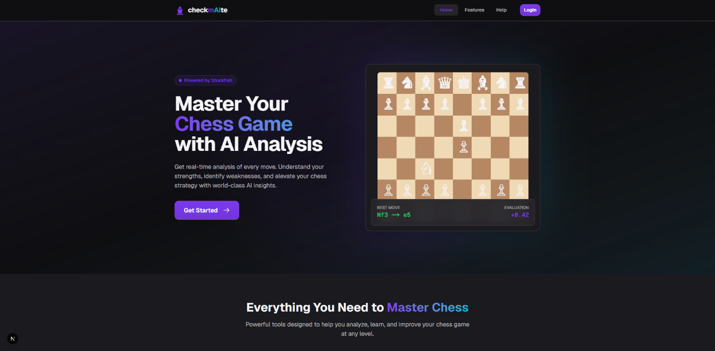
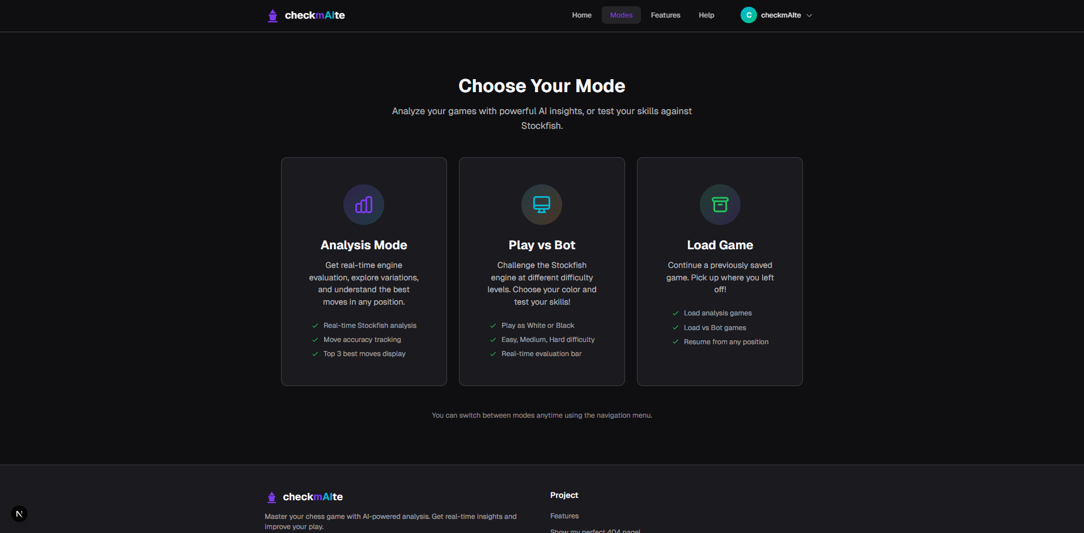
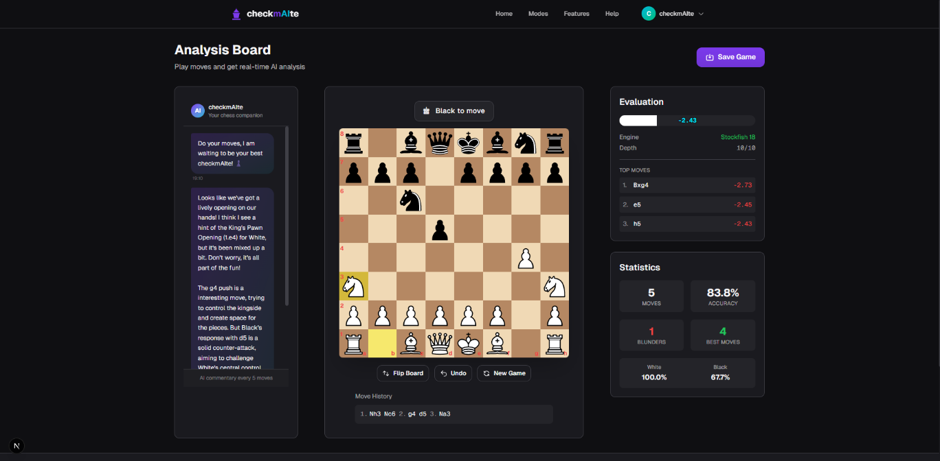
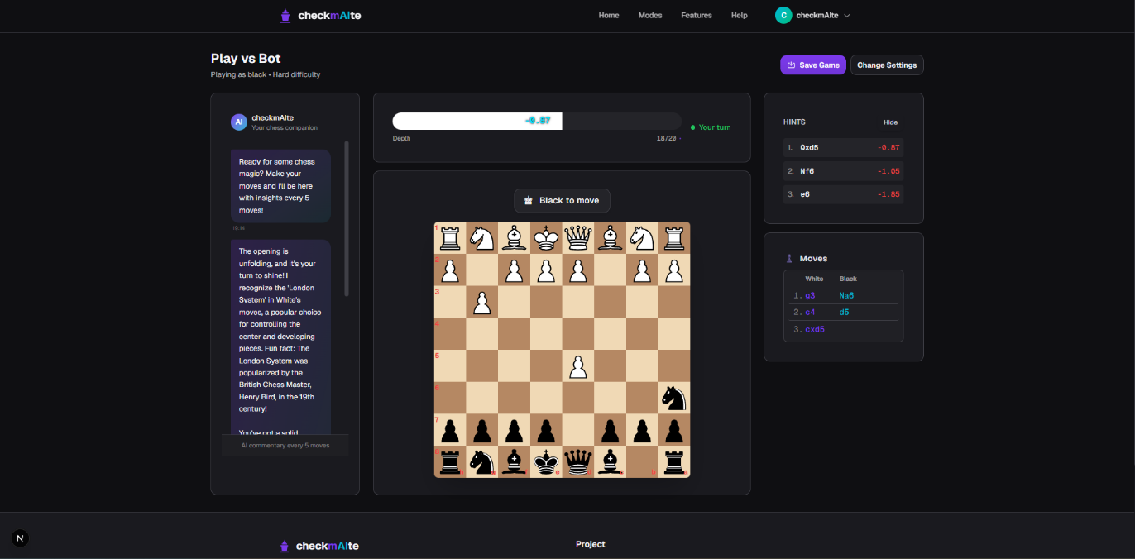

Repository
https://github.com/Svetliox/checkmAIte

